**SARAH SALEEM AKHTER ASSIGNMENT # 03**

**QUESTION 01:** **Take 50 startups of any two countries and find out which country is going to provide best profit in future.**

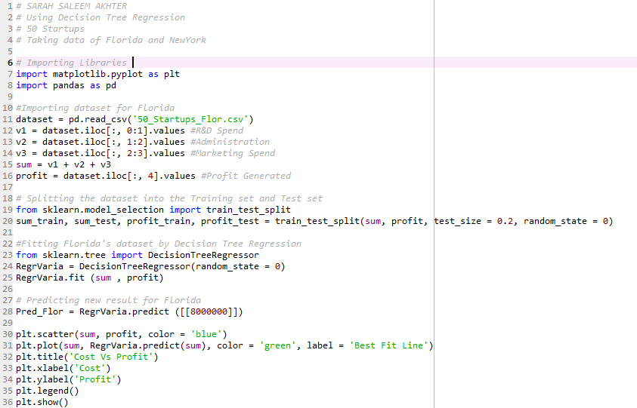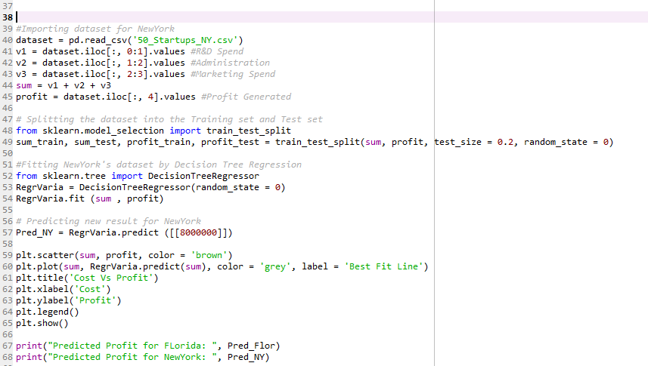

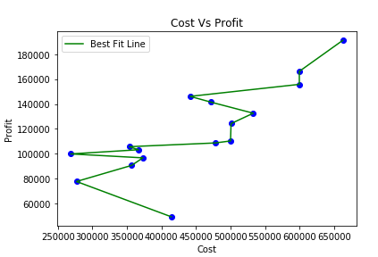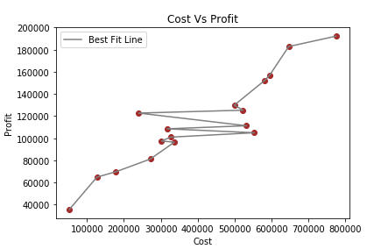  
**OUTPUTS:**

  
 Therefore, as shown in the graph, NewYork would provide better results in future than Florida.

**QUESTION 02: Annual temperature between two industries is given. Predict the temperature in 2016 and 2017 using the past data of both country.**

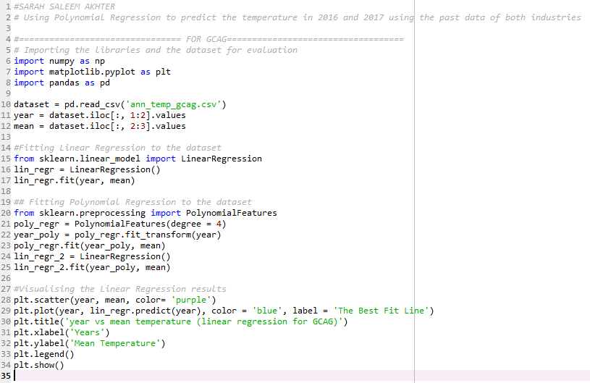

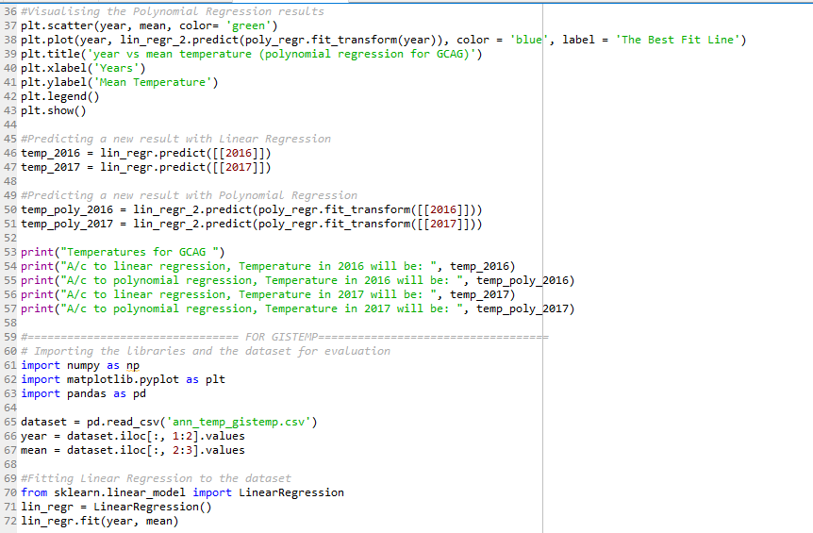

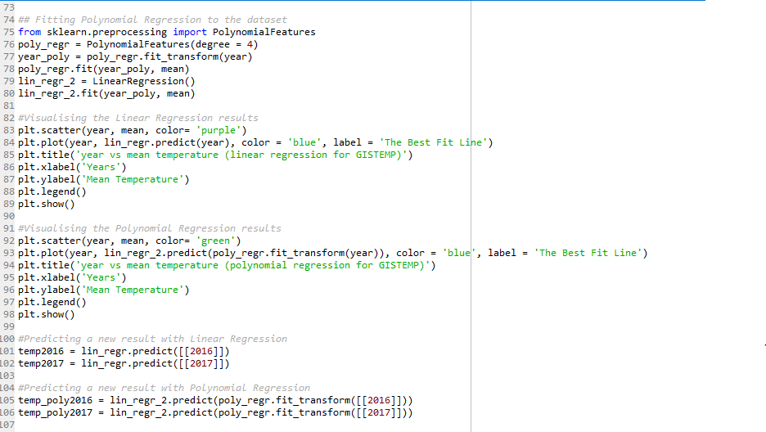

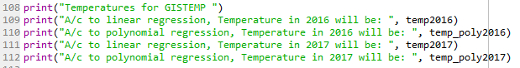

**OUTPUTS:**

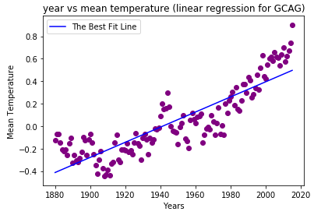 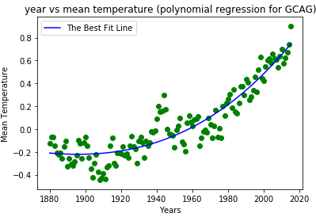

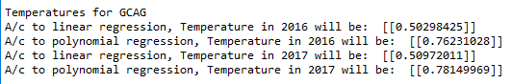

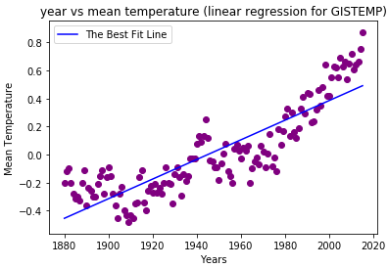 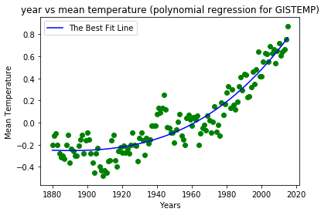  
  
  
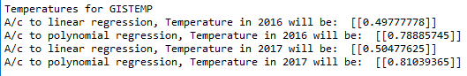  
  
  
**QUESTION 03: Data of global production of CO2 of a place is given between 1970s to 2010. Predict the CO2 production for the years 2011, 2012 and 2013 using the old data set.**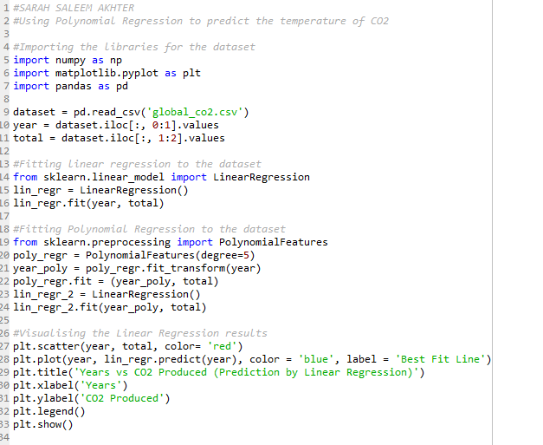  
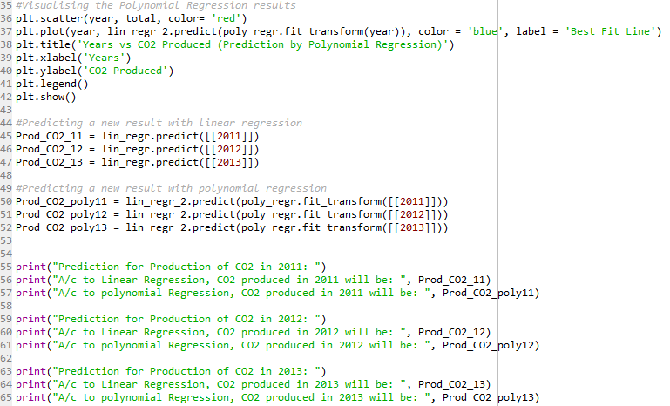

**OUTPUTS:**

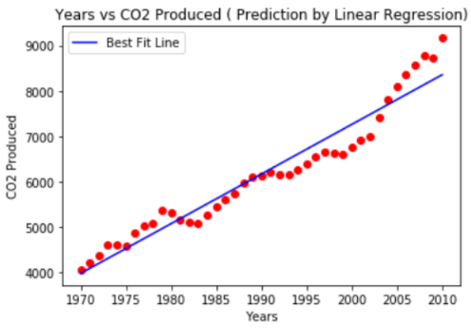   
  
 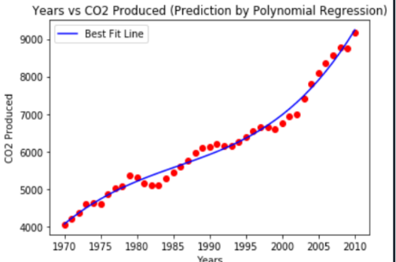

**A/c to Linear Regression:**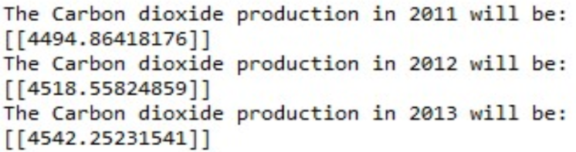   
  
**A/c to Polynomial Regression:**

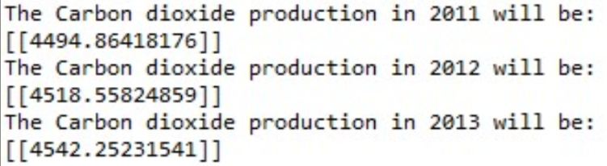

**QUESTION 04: Housing price according to the ID is assigned to every-house. Perform future analysis where when ID is inserted the housing price is displayed.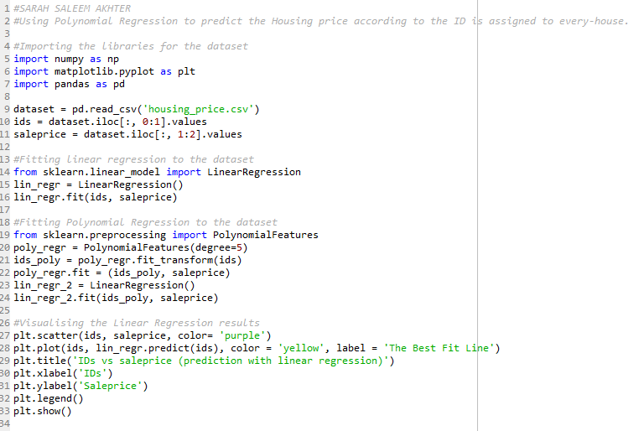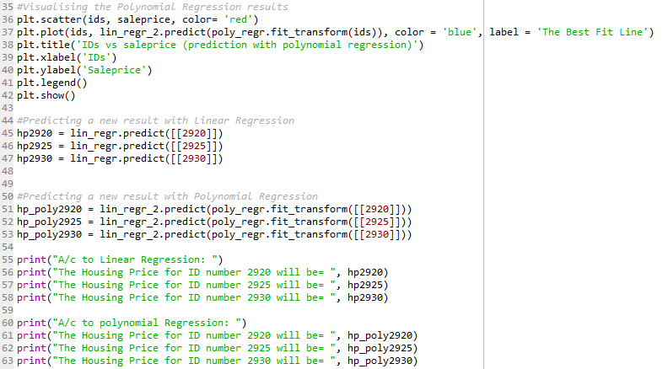 OUTPUTS:**

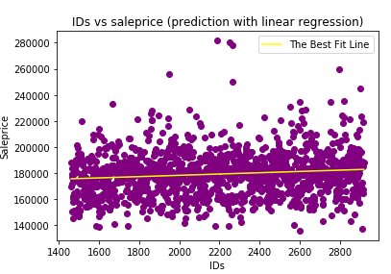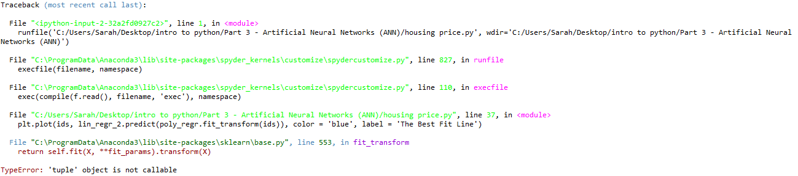

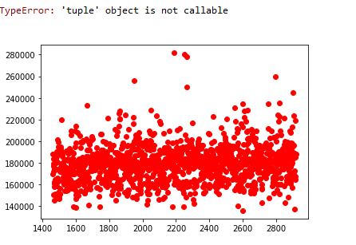

**QUESTION 05: Data of monthly experience and income distribution of different employs is given. Perform regression.**

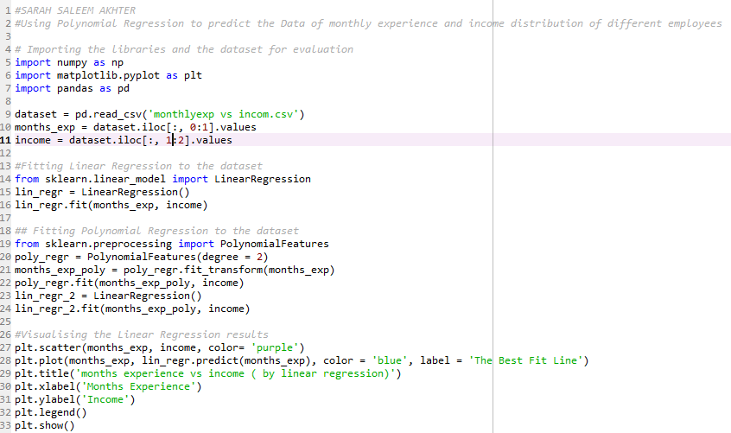

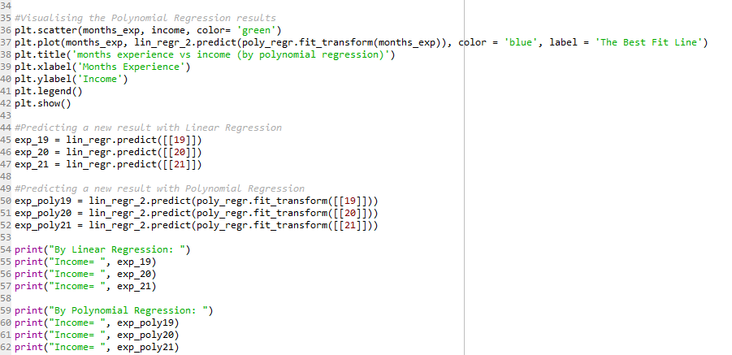

**OUTPUTS:**

